
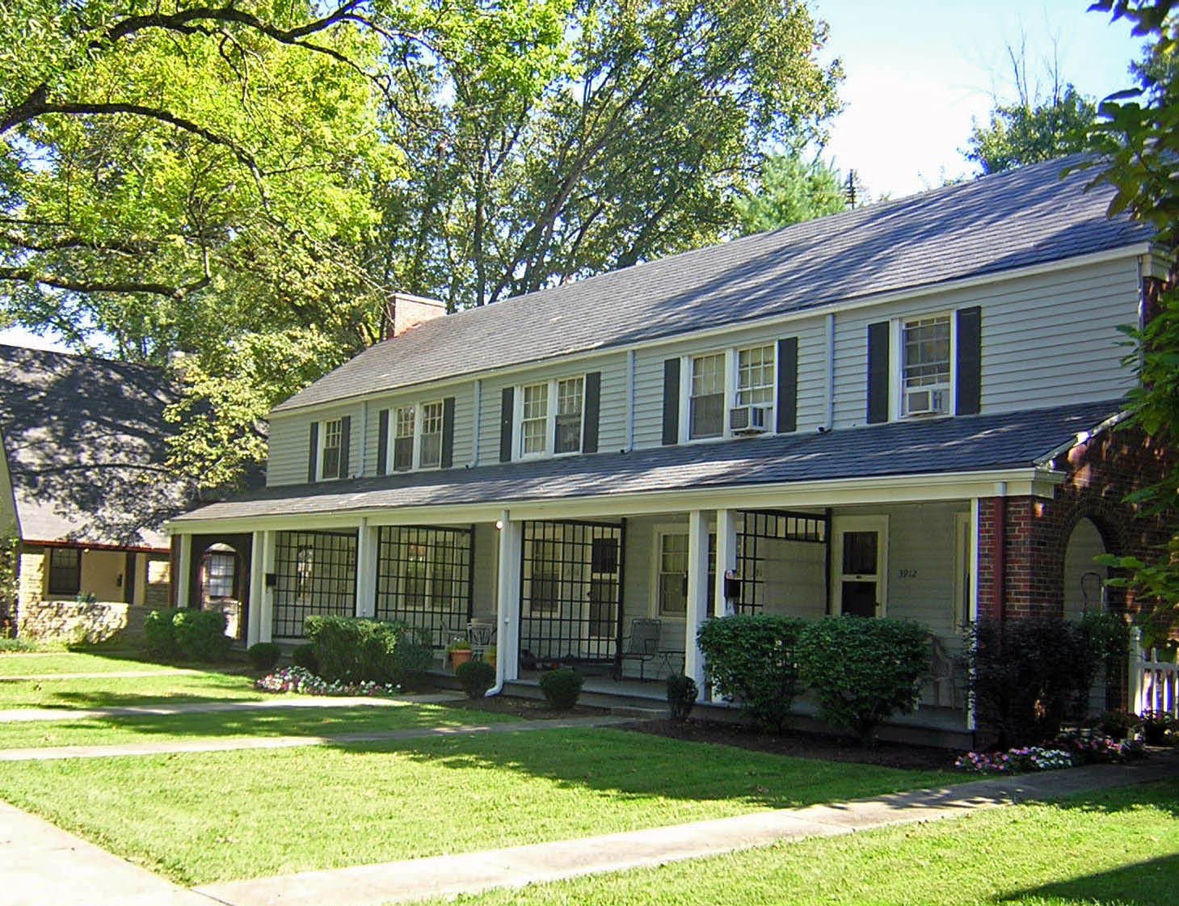

3920 Beech Street

Unit includes…

* Two-bedroom townhouse

* End unit with additional windows & large yard

* Eat-in “designer” kitchen, fully-equipped with dishwasher & pantry

* Full basement with washer and dryer hook-ups

* Fenced backyard with private patio

* Covered front porch

* Detached garage

* Cable ready

* Pet-friendly environment, call for details.

895.00 per month

For Inquiries or to make an appointment for a showing for this townhouse, call
513-861-2861 or 513-617-5747 or 545-4952



For Inquiries or to make an appointment for a showing for this townhouse, call
513-861-2861 or 513-617-5747

